How BIG has Fintry been?

If asked how many folk live in Fintry most of us would say probably around the 500 mark. If you take in our wider catchment of the parish of Fintry or even the voting area we often put it about 600 plus.

But the population of Fintry has fluctuated over the years. Going back in time it is actually quite an astonishing set of figures.

Let’s go back to the 17th century. Scotland’s whole population then was about 800,000.
It was about 8 times smaller than today. Yet Fintry went the other way. Our head count was almost twice as big as today!

Around 1660 it was a remarkable 1,000 plus. They largely lived in the old village area surrounding the church, known as the Clachan of Fintry, or hamlet. Clearly many signs of housing from back then have long gone. Many would have lived on around 40 small farms within the wider boundaries of Fintry.

This seems utterly astonishing when you think of how small Clachan of Fintry is today!

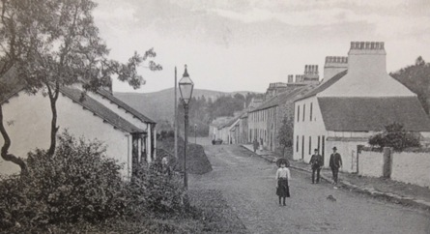

By 1780 it had shrunk to 550.
Then with the coming of the larger mill around the year 1800, the population peaked once again at over 1,000. Most of these folk lived in the Newton of Fintry, the main village that we know today. But just imagine how this really looked. Back then the three main new housing estates of Menzies Avenue, Culcreuch Avenue and Dunmore Gardens all did not exist. So little flats in the old stone buildings on Main Street each housed families of around 10 folk in a couple of rooms.

This population collapsed with the closure of the mill and families had to move on to find new work.

More accurate census figures later show the population as 279 in 1931; 356 in 1937; the lowest ever of 286 in 1961; then following the building of Culcreuch Avenue it grew to 438 in 1971 and the Menzies estate around 1973 took it over 500. The 2011 census declares it at 717.

David Smith Fintry Museum Society

